**Who are we?**

At Populytics we do research into the preferences of Dutch citizens about public policy dilemmas. Examples include wind turbines, refugee centers, and health care budgeting. We do this, by carrying out large-scale online consultations using the scientific [PVE-method](https://www.tudelft.nl/en/tpm/pve).

By gaining insight into the worries and preferences of citizens, we provide governments (and other decision makers) with helpful insights to make better decisions.

**What is our question?**

We often see a large group of respondents with moderate preferences, which often makes up about 50% of the sample. In terms of demographic characteristics such as age and gender this block is often representative of the population. Additionally, this is a group that often says they haven’t actively voiced their opinion on the research topic at hand. Therefore we colloquially dub this group ‘the silent majority’.

It seems unlikely that all citizens within such a large segment have the same preference for the same reason. Multiple hypotheses can be formed for their moderate preference profile. Are they disinterested in the topic? Or unknowledgeable? Or is it a well-considered, nuanced position? And in the latter case, why? Are they reluctant to change, or realistic about social change? Or is something else entirely at play?

We would like to get to know this silent majority better. Are there recognizable, coherent and recurrent subgroups? What questions or (demographic) factors allow us to identify these subgroups?

**Some background information on our projects**

At Populytics, we develop consultations on specific policy dilemmas. All our consultations are specifically developed for this one policy issue and are therefore unique. Examples of the main questions we ask our participants are:

* What should the government take into account when making choices about the Lelylijn?
* What measures should TU Delft take to define its collaboration with the fossil industry?
* What should the municipality arrange at and around reception locations for refugees?
* What should we make more room for in Amsterdam in the future? And what should we make less room for?

But this doesn't mean that the results cannot be compared. All consultations have a standard element in common that can be used to analyze them as a whole. This element is the part where participants formulate their concrete advice on the policy dilemma. We call it the choice task. Let us explain:

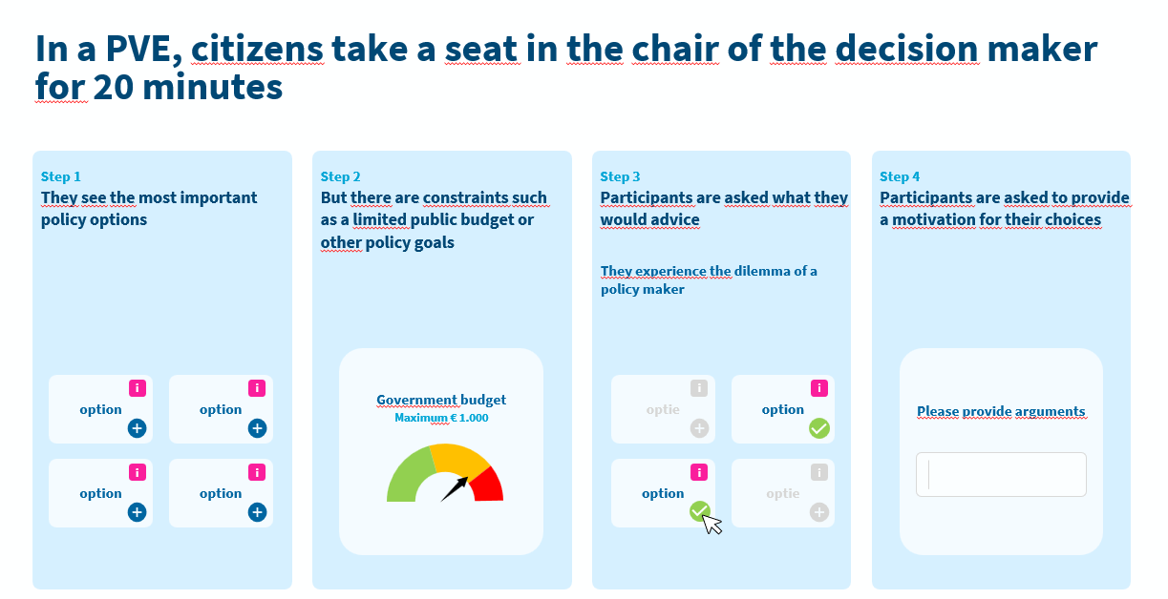

Participants always provide advice on the subject in a segment of the consultation called the ‘choice task’. A choice task always consists of several **options** to choose from, a **restriction** so that respondents cannot pick all options (or have to select a minimum amount). Often, the options also have quantified **properties**, that provide information on the effect of each option.

We use 3 types of choice tasks in our consultations:

1. Pick-mode  
   This choice task consists of concrete options that are dichotomous. They can either be selected or not selected, and therefore have values 0 or 1. Participants provide their advice by selecting a portfolio consisting of one or more options.  
   Example: our consultation on collaboration with the fossil industry <https://fossilfuels_gesloten.raadpleging.net/>

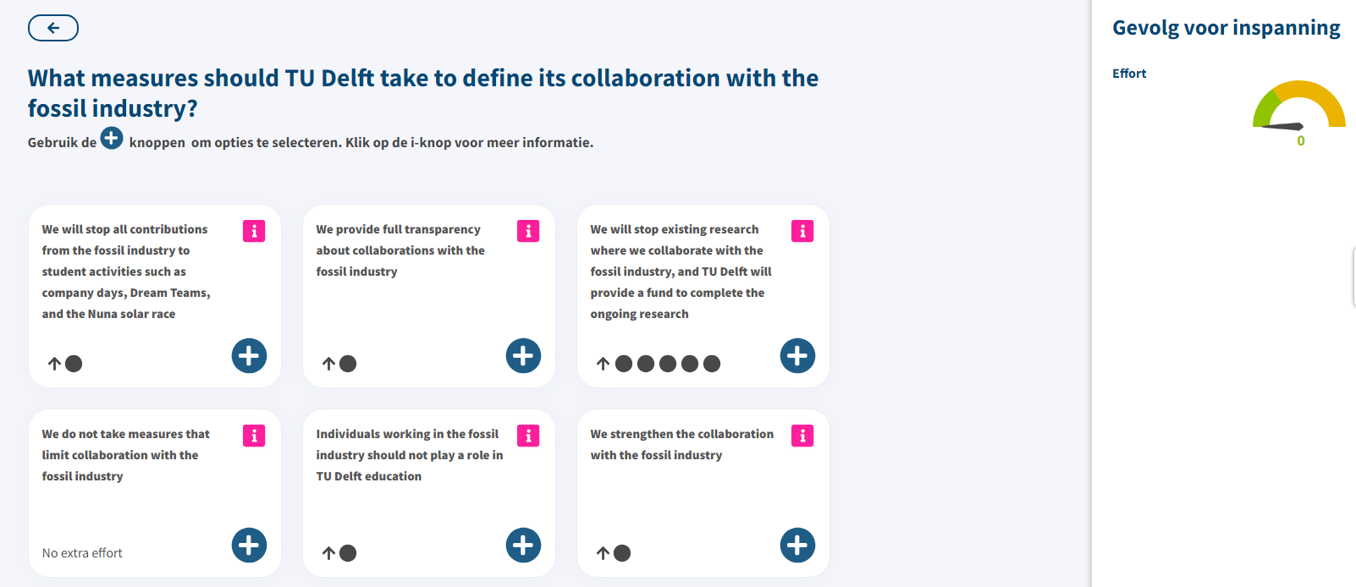

1. Slider-mode  
   This choice task consists of options that are continuous. They can be gradually selected. Depending on the settings 1 to 1000 positions are possible. The values are anything between 0 and 1 (0 and 1 included), or between -1 and 1 (-1 and 1 included) (depending on the design of the choice task). Also here, participants provide their advice can create a portfolio consisting of a combination of options.  
   Example: our consultation on the use of public space in Amsterdam <https://amsterdammakesspace.raadpleging.net/>

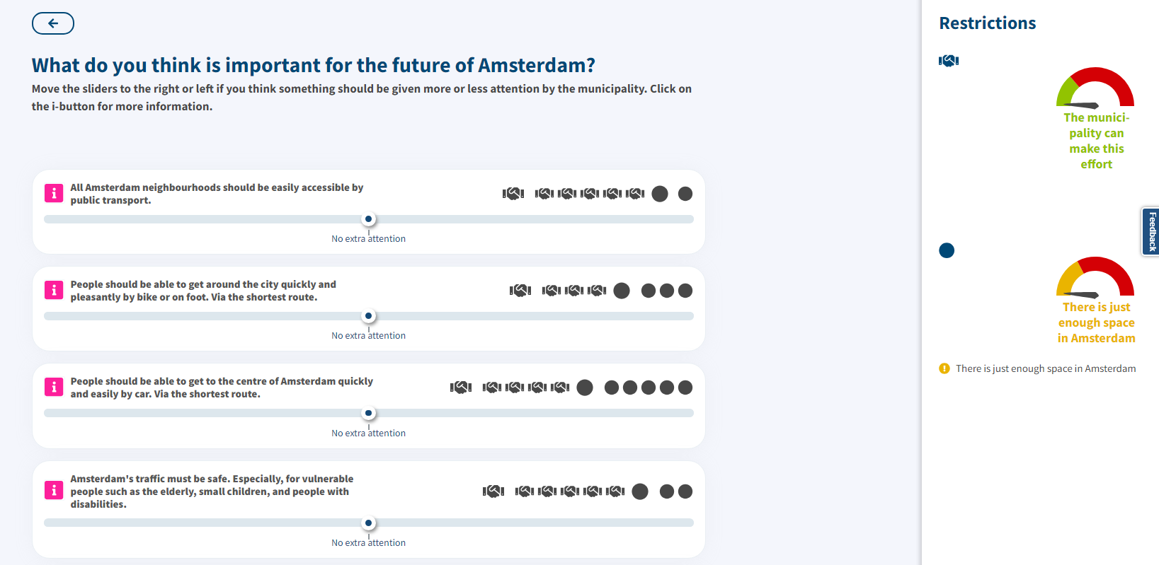

1. Points-mode  
   This choice task consists of a fixed number of points that must be distributed over the options. So: each option can have anything between 0 and the maximum number of points.  
   Example: our consultation on providing shelter for refugees in a municipality <https://samenleven-digipanel.raadpleging.net/>

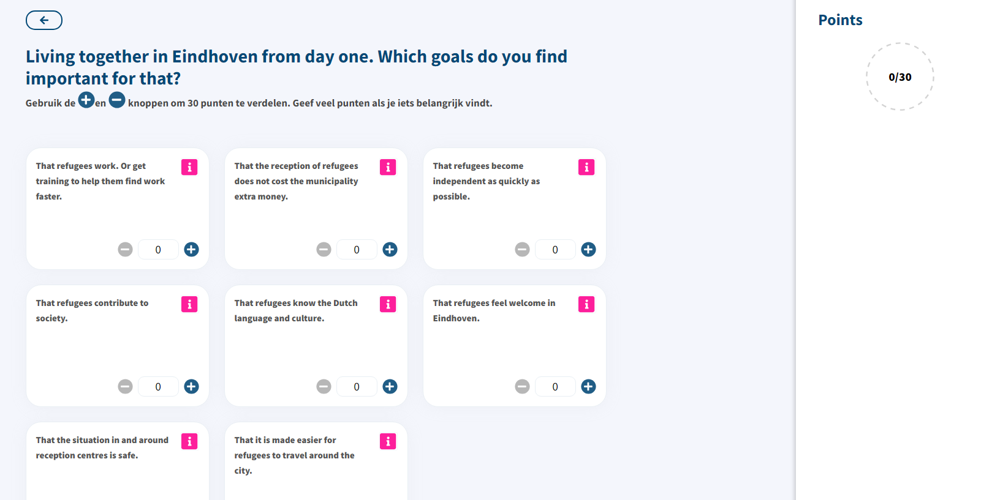

**Data structure of choice tasks**

The dataset contains the data from the choicetasks. Some studies have 1 choice task, other studies have 2 choice tasks.

The variables connected to the results of the choice tasks are named ct1_x, mct1_x, ct2_x and mct2_x. `x’ stands for any number to identify the option. The number of options differs for every choice task. For this assignment, it is not necessary to know the actual text of the option for each of the studies.

* The variables that start with ‘ct’ contain the value of the choice connected to this option. The values for each respondent depend on the type of choice task that was provided:
  + Pick mode: 0 or 1
  + Slider mode: anything between 0 and 1 (0 and 1 included) or between -1 and 1 (-1 and 1 included)
  + Point mode: any integer between 0 and the maximum points to be distributed.
* The variables that start with ‘mct’ are the written motivations for the choice. This is an open field.

**What is the ‘silent majority’?**

In our studies, we often use a type of class analysis (Latent Class Cluster Analysis, LCCA) to identify subgroups in the sample based on their choices. As indicated in our introduction, we often see a cluster that has very average preferences and that is representative of the population in gender, age and education.

A result of a LCCA can look like this:

7,500 citizens advised on options to improve a railway. Below, you see a screenshot of the choice task. You see only the first 5 options, but in total 8 options were shown. Participants could give advice using the slider tip. The main restriction was affordability for the government (upper right speedometer).

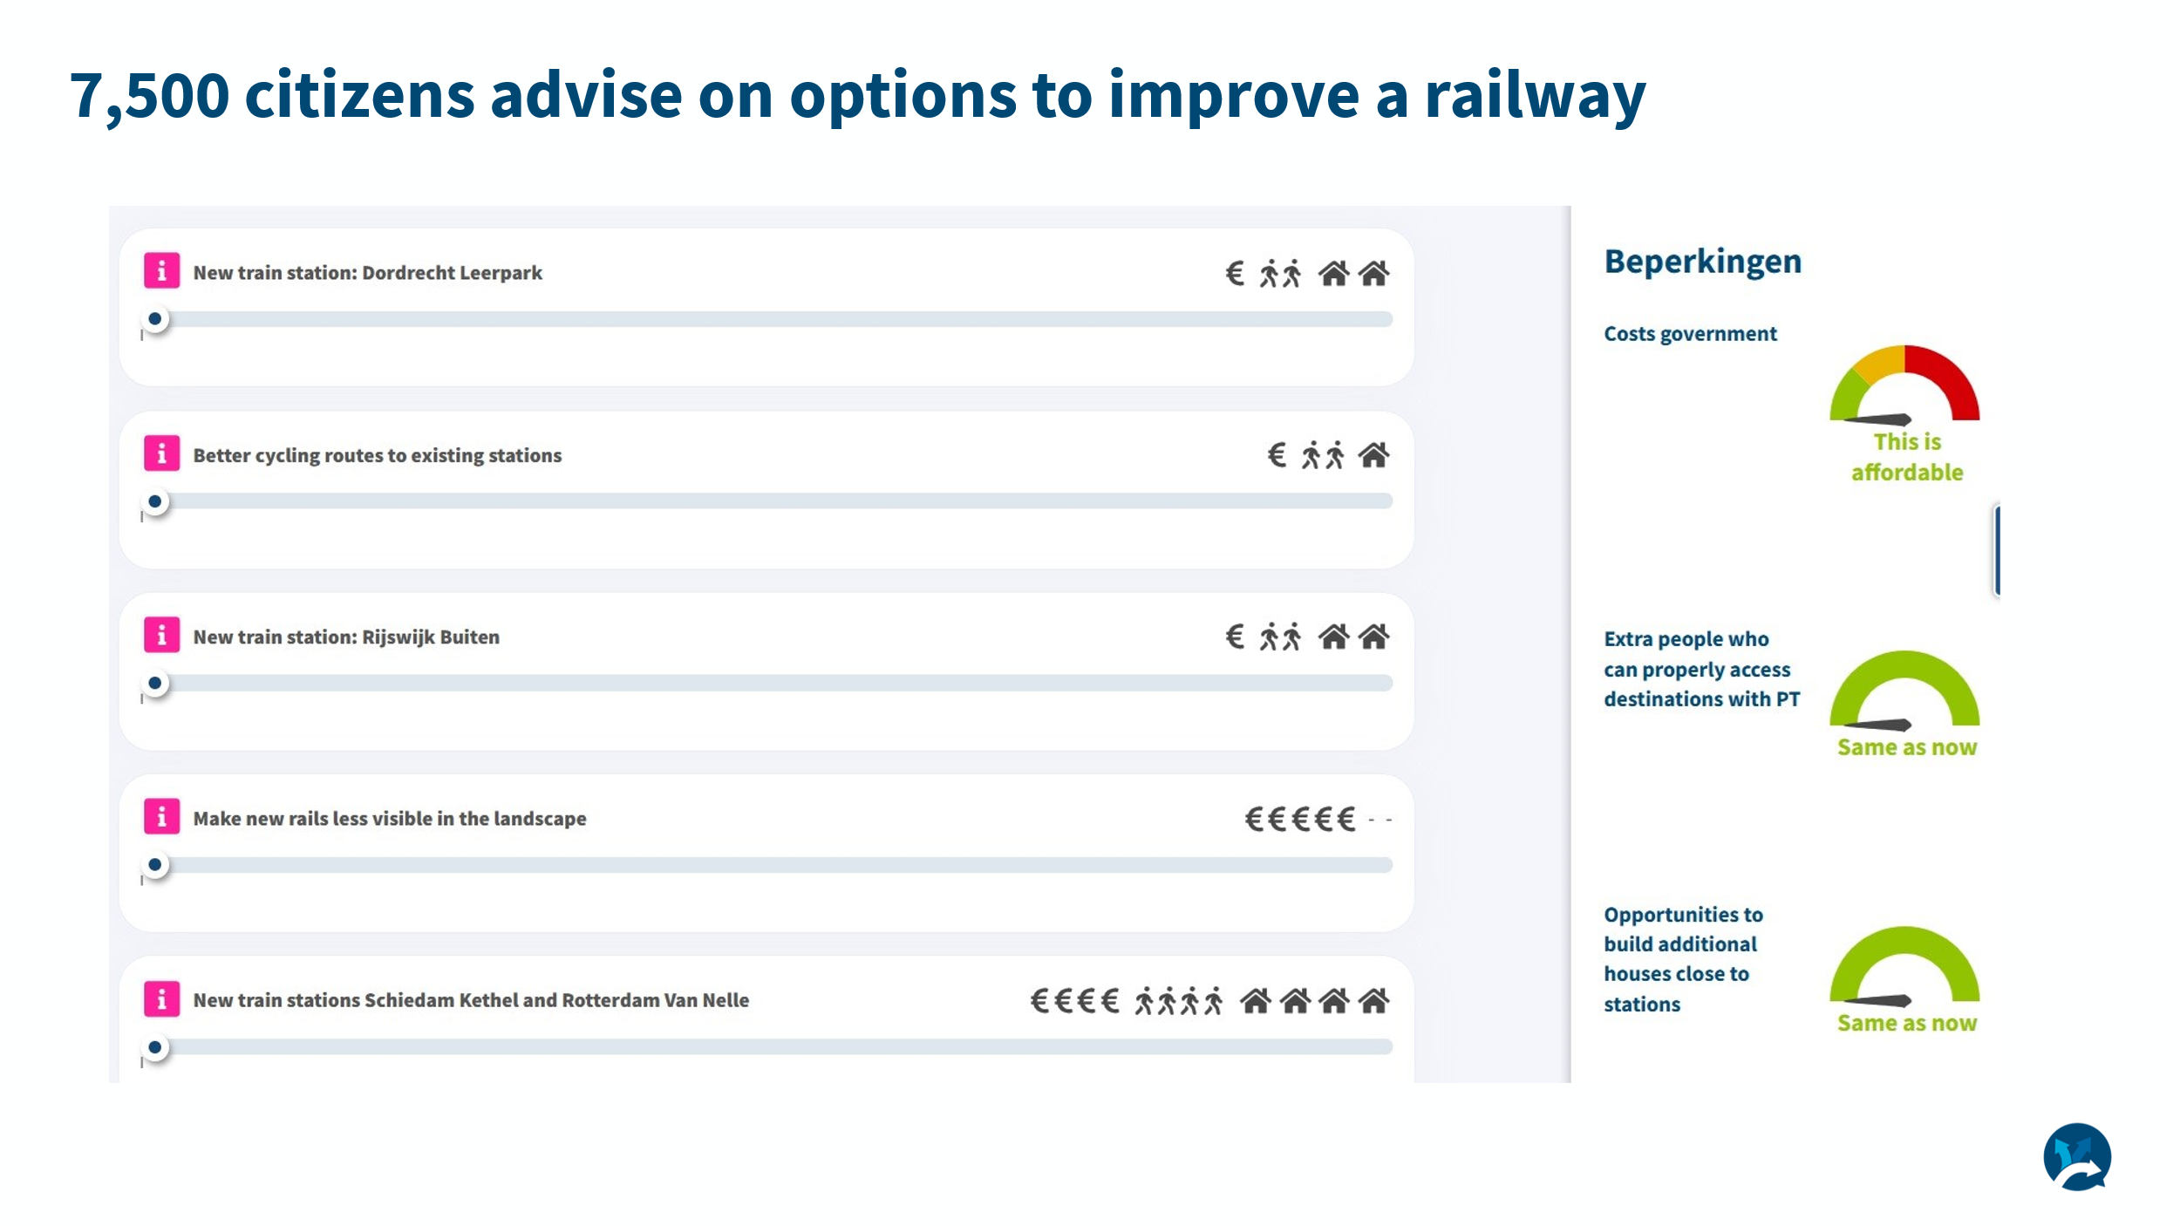

Below, the results of the LCCA are shown. We identified 4 relevant clusters. On the left, you see the average score of each of the options. On the right, you see the average score of each of the 4 clusters. Below each column, you can see the size of the cluster (share of total respondents). Cluster 1 (61% of the respondents) has a profile that is rather close to the average.

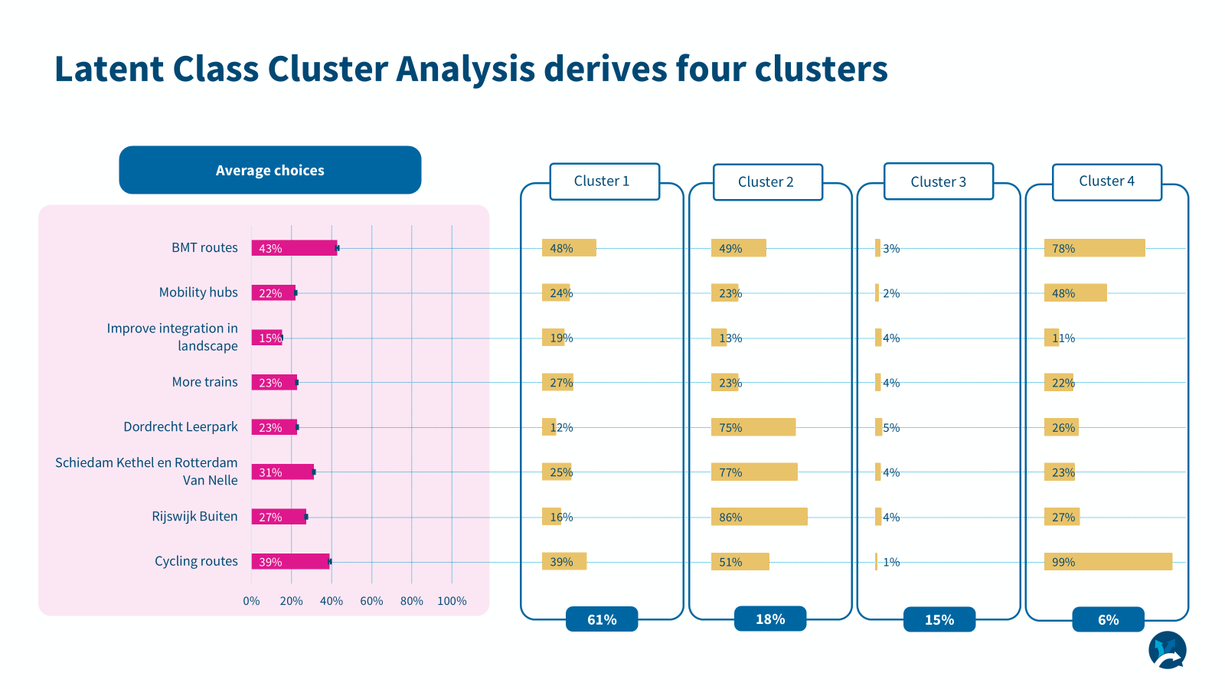

The results of these LCCA's are not included in the dataset. Instead, we expect you to identify the respondents that belong to the ‘silent majority’ in each study. This could be done by 1.) calculating the mean or median choice for each of the options in a study and 2.) comparing the choice of each respondent with this mean or median. A suggestion is to calculate 1 measure, such as the mean deviation from the mean or median for all of the options of a choice task.

**Overview of studies**

Below, you can find an overview of the studies used. There is a link to every consultation. They are mostly in Dutch. Also, a very short description of the main topic is provided.

|  |  |  |
| --- | --- | --- |
| **Study** | **URL** | **Topic** |
| Lelylijn_open | lelylijn2.raadpleging.net | Research question: **What should the government take into account when making choices about the Lelylijn?** |
| Lelylijn_panel |  | Research question: **What should the government take into account when making choices about the Lelylijn?** |
| Mobiliteitsvisie_panel | mobiliteitsvisie_panel.raadpleging.net | Research question:  **To which goals should the government give more or less attention?** |
| Oudelijn_open | oudelijn.raadpleging.net | Research question:  **What choices should the government make for the Oude Lijn?** |
| Oudelijn_panel | oudelijn-panel.raadpleging.net | Research question:  **What choices should the government make for the Oude Lijn?** |
| Notaruimte_open | nota-ruimte-panel.raadpleging.net | Research question:  **What should the government take into account when allocating space?** |
| Notaruimte_panel |  | Research question:  **What should the government take into account when allocating space?** |
| Nmp | nmp.raadpleging.net | Research question:  **What do you consider important when making environmental policy?** |
| Zoeterwoude | energiezoeterwoude.raadpleging.net | Research question:  **How much sustainable electricity do we want to generate in Zoeterwoude? And where?** |
| Delftwarmtenet | warmtenetdelft.raadpleging.net | Research question:  **What should the municipality do for you when developing a heating network?** |
| Windprovincieutrecht | utrechtwind12.raadpleging.net | Research question:  **What should the province take into account when making choices about wind turbines?** |
| Pplg | noord-holland.raadpleging.net | Research question:  **What should the province strive for?** |
| Vrapwe | vervoerregiopanel.raadpleging.net | Research question**:**  **What should we pay attention to when making choices about traffic and transport?** |
| Energiesysteem2050 | <https://energiesysteemoffline.raadpleging.net/> | Research question:  **What choices need to be made when designing the energy system?** |
| Energievisieutrecht | energievisie.raadpleging.net | Research question:  **What should the province ensure when making choices about the future energy system?** |
| Fossilfuels | fossilfuels_gesloten.raadpleging.net | Research question:  **What measures should TU Delft take to define its collaboration with the fossil industry?** |
| Nprespwe | nprespwe2024.raadpleging.net | Research question:  **Clean energy in the future: what should the government take into account?** |
| Alblasserwaard | windalblasserwaard.raadpleging.net | Research question:  **What do you think the municipalities of Gorinchem and Molenlanden should take into account when making choices about wind turbines?** |
| Eindhoven | <https://samenleven-digipanel.raadpleging.net/> | Research question:  **Living together from day one: what do you find important?** |